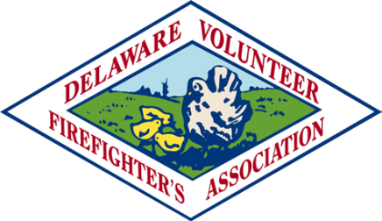

**Appointment of Delegates and Alternates to the Annual Conference**

___________________________ Fire Company

The following members have been appointed or elected as a Delegate or Alternate

to the Annual DVFA Conference.

The Conference will be at the Hyatt Place Dewey Beach and Rehoboth Beach Convention Center

September 22 – 25, 2025

**Luncheon will be Thursday, September 25 at the Hyatt Place Ballroom – Dewey Beach**

**Check-in and Social will start at 10:30 AM – Lunch at 11:30 AM**

**DELEGATES ATTENDING** (Two only)

**Check, if Attending luncheon**

**ALTERNATES ATTENDING**

(Two only) **Check, if Attending luncheon**

1. _______________________ ______

2. _______________________ ______

1. _______________________ ______

2. _______________________ ______

The following members, current DVFA Officers and DVFA Past President’s, desire to attend the luncheon on a first – come, first – serve basis. Seat allocations will be based on available space.

1. _______________________

2. _______________________

3. _______________________

4. _______________________

Return this form: **No later than JULY 15th**

**NOTICE:** There is a **NO-SHOW** policy in affect for ALL Conference events. If you register and fail to attend, your Company will be billed accordingly.

Return to: **DVFA Office**

**P.O. Box 1849**

**Dover, DE. 19903-1849**